Assignment 2: Dynamics of Real Sprinkler System
You will want to click on the figure in section 4.5 to see the enlarged view of this image and maybe print it out for convenience.
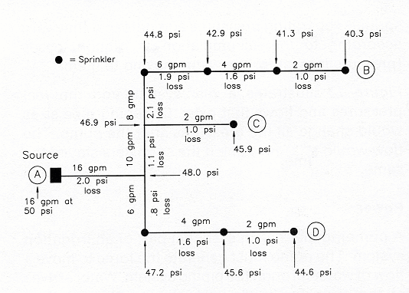
The purpose of this exercise is for you to bring together the information on flow, friction, pressure, pipe sizing, and sprinkler nozzle discharge into a real situation.
To do this exercise you will need to understand how water flow divides within a pipe network and where it will go and why. The pump puts water into the pipe network, where does it come out?
You will also need to understand pressure in a pipe network. What happens to pressure (note the changes in flow) in pipeline segments (between sprinklers) with water flowing through the pipeline to discharge through sprinklers?
Finally, friction loss is occurring in this dynamic situation of water flowing. You need to understand what causes friction loss but more importantly you need to be able to explain why it is changing throughout the system. What is changing to cause friction loss to change.
If you know the answers to these questions, then proceed to the assignment. Good luck! If any doubt, go back and study more. This is important information for you to take away from this course.
Download the assignment as a word file and then answer the questions. Once you have completed this, please save your file with your name in the filename (e.g. DavidSmith_Assignment#1) and then upload the file. I will then grade and give you feedback to your answers.
Note that you will not be allowed to upload assignments after the due date, and you will lose any points associated with this assignment for your final grade.

Assignment Questions:
Explain what happens to the flow of water and to the pressure in this system. The system is running (irrigating) so it is a dynamic situation.
1. Why do the sprinklers differ in operating pressure in this real system? And, do you note a trend or pattern in the changes starting at Pump (A) and moving out to individual laterals noted as (B), (C) and (D).
Think about what is happening to pressure overall and tell me what is happening to the operating pressure in various pipe segments and why. I can read the numbers on the diagram so do not just give those back to me because you will get no points for doing that.
Tell me what is going on in terms of flow (area and velocity) and pressure (pressure and friction loss) in the pipeline segments.

2. Note the water flow, in GPM, given along the segments of the pipelines in the figure. Tell me why the flows to each and within each of the three laterals are what they are. Note that the laterals have sprinklers on them and laterals are labeled as (B), (C) and (D). You can use these labels to refer to the irrigation system. Hint: what is the flow in and where does it go and why.

3. Note the pressure losses along the various segments of the pipeline. Think in terms of flow, velocity, and pressure. Tell me why the pressure losses vary the way they do between (A) and the ends of laterals (B), (C) and (D). Hint: Give a one sentence overall reason and then pick a couple pipeline segments and tell me why the friction loss is what it is there.

